**Career Objective:**

"Seeking a Sales Officer role in a dynamic organization where I can apply my communication skills, market understanding, and customer service abilities to drive sales growth and build strong client relationships. With a background in teaching and public engagement, I bring persuasive skills and a results-oriented mindset. I aim to contribute to the company's success while growing professionally in a competitive and target-driven environment."

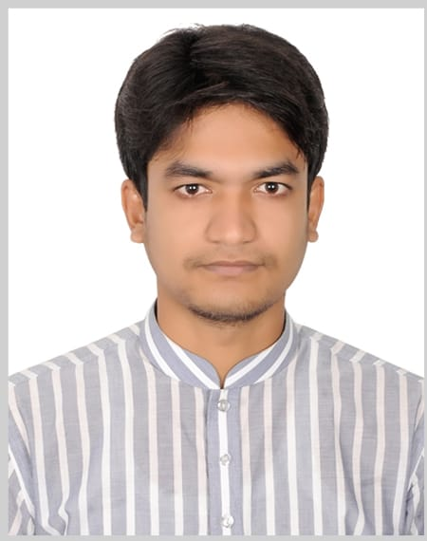

**MD. SHAKIL AHMMED**



# **Contact:**

+88 01811310641

[sajol5094@gmail.com](mailto:sajol5094@gmail.com)

Natore Sadar, Natore

**Skill Highlights**

* Excellent Communication and Organizing Skill
* Leadership & Teamwork
* Project Management
* People Convincing
* Public Speaking
* MS PowerPoint & MS Excel
* MS Word & Internet

# **Personal Proficiency**

* Good Communication Capacity and Social Networking
* Time Management
* Well Organized & Dedicated

# **Language Proficiency**

Bangla – Fluent

English – Standard

# **Educational Qualification**

**Higher Secondary Certificate (H.S.C.)**

Institute : Nstore City College, Natore

Board : Rajshahi

Passing Year : 2020

GPA : 2.75 (out of 5.00)

Group : Business Studies

**Secondary School Certificate (S.S.C.)**

Institution : Pirganj High School, Natore

Subject/Group : Business Studies

Result : GPA- 3.94 (out of 5.00)

Board : Rajshahi

Passing Year : 2015

# **Personal Details:**

* Father’s Name: Md. A. Zabbar
* Mother’s Name: Mst. Shahanz Parvin
* NID: 2405012879
* Religion: Islam
* Date of Birth: 25 December 1999
* Address: Birahimpur, Pirganj, Natore Sadar, Natore

# **Extra-curricular & Achievement**

* Obtained Basic Computer Certificate.
* Blood Donation Organization of Natore.
* Social Work in Pirganj
* Photography in the area of Natore

# **Personal Interests**

* Strength Training
* Journey
* Social working
* Reading